In this document, I will give you explain of how maked the network design of the assignment using the application GNS3 version 1.3.13. How first step, I downloaded the GNS3 both the ISO router Cisco 7200. Next, we import the ISO image into the GNS3.

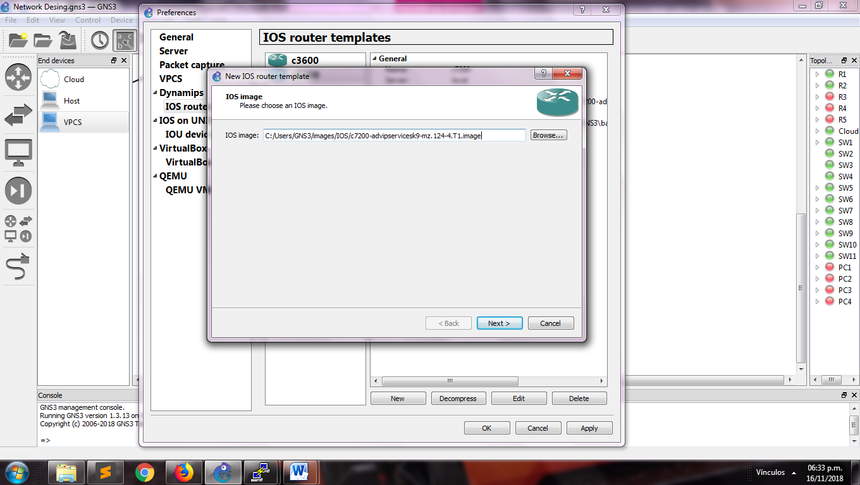

View to import the ISO image

Inside our section “Routers”, we can find the router downloaded for be used. In this moment we can drag the components inside of our workspace.

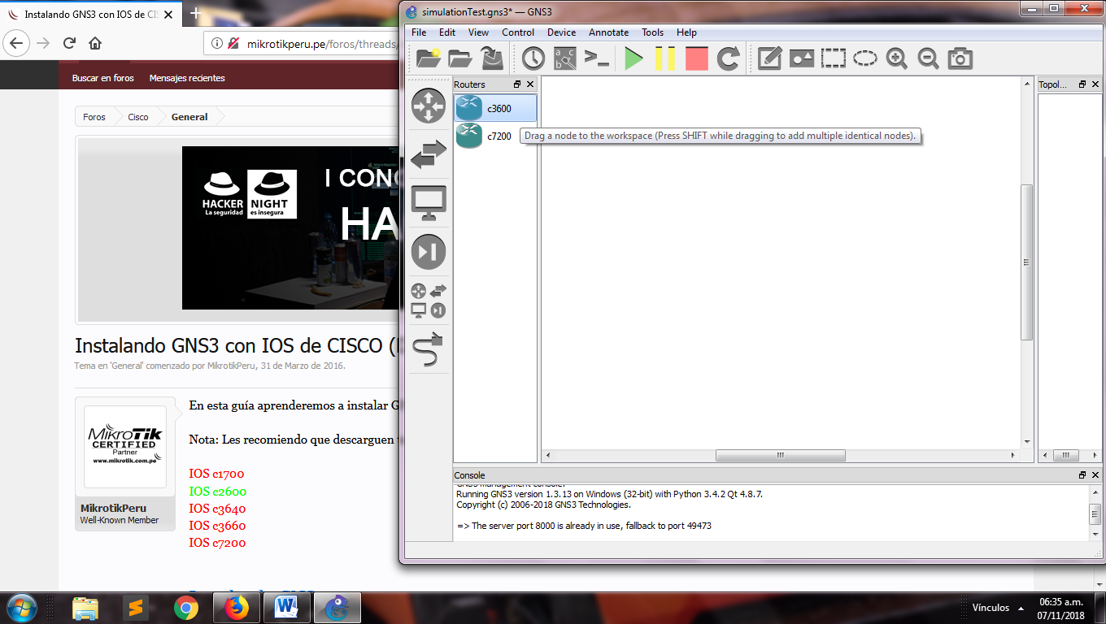

View of the workspace

We can design our topology using all the components that GNS3 has, in this components we will find routers of CISCO, switches, hosts, VPCS, cloud for the connection to internet, hubs and wire for join the components.

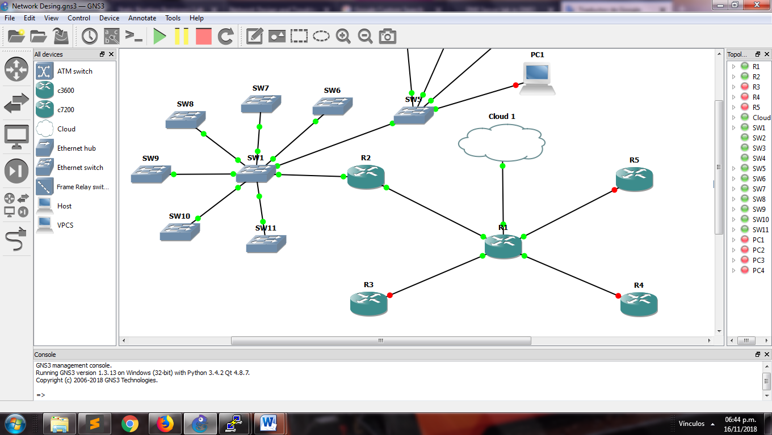

View of star topology

We will use two ips for our network; the ip address public is 130.140.150.160/26 with this we can connect to internet and our ip address private 192.168.168.0/24 which this stablish inside the company. It has four departments, connected in the same network each other with different number of host.

Due to, we will apply subnetting to the ip address private for we will obtain four different networks for each department. This distribution will be showed in the table below.

|  |  |  |  |  |  |  |  |  |
| --- | --- | --- | --- | --- | --- | --- | --- | --- |
| Nº | Requested host | Found Host | Network address | Mask | Decimal mask | First usable IP | Last usable IP | Broadcast  address |
| Finance | 67 Computers  1 Printer  1 server | 126 | 192.168.168.0 | /25 | 255.255.255.128 | 192.168.168.1 | 192.168.168.126 | 192.168.168.127 |
| IT | 37 Computers  1 Printer  1 Server | 62 | 192.168.168.128 | /26 | 255.255.255.192 | 192.168.168.129 | 192.168.168.190 | 192.168.168.191 |
| HR | 17 Computers  1 Printer  1 Server | 30 | 192.168.168.192 | /27 | 255.255.255.224 | 192.168.168.193 | 192.168.168.222 | 192.168.168.223 |
| Marketing | 9 Computers  1 Printer  1 Server | 14 | 192.168.168.224 | /28 | 255.255.255.240 | 192.168.168.225 | 192.168.168.238 | 192.168.168.239 |

Table subnetting information

Each network will be configured with a VLAN, listed of the next way:

|  |  |
| --- | --- |
| Department | VLAN number |
| Finance | 100 |
| Information Technology | 200 |
| Human Resources | 300 |
| Marketing | 400 |

Table VLAN information

In all the routers be to executed the follow lines inside its console. This will be available after to start the router.

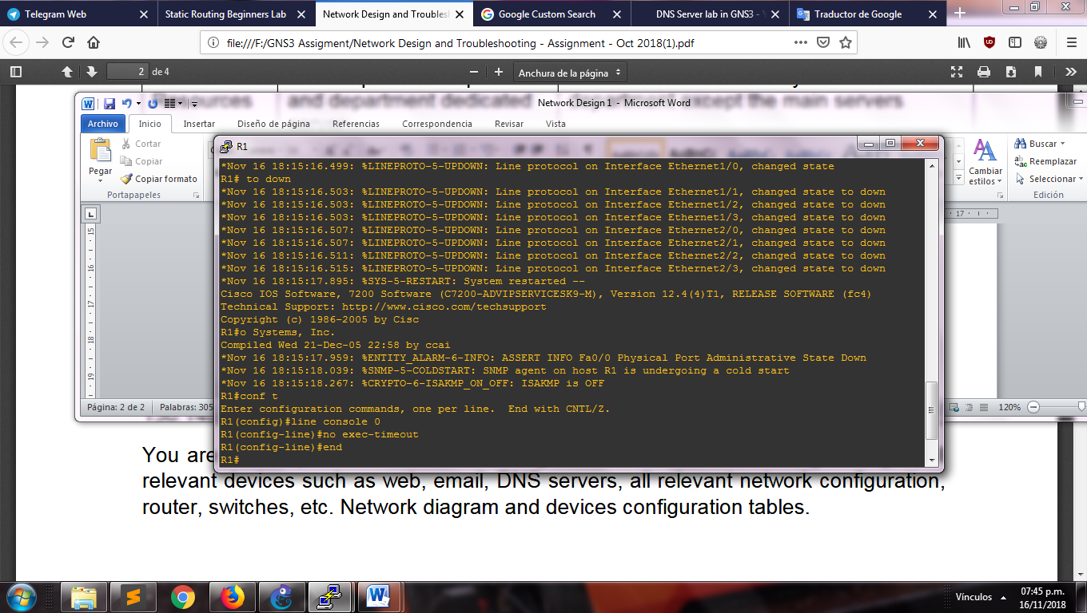

Commands lines for timeout

These lines disable the timeout for that the router doesn’t disconnect after some seconds of inactivity.

We configure the slots in each router what it will permit us have the interface for the connections between the components. In our case, we will use a slot with eight interfaces in each router. This will show in the picture below:

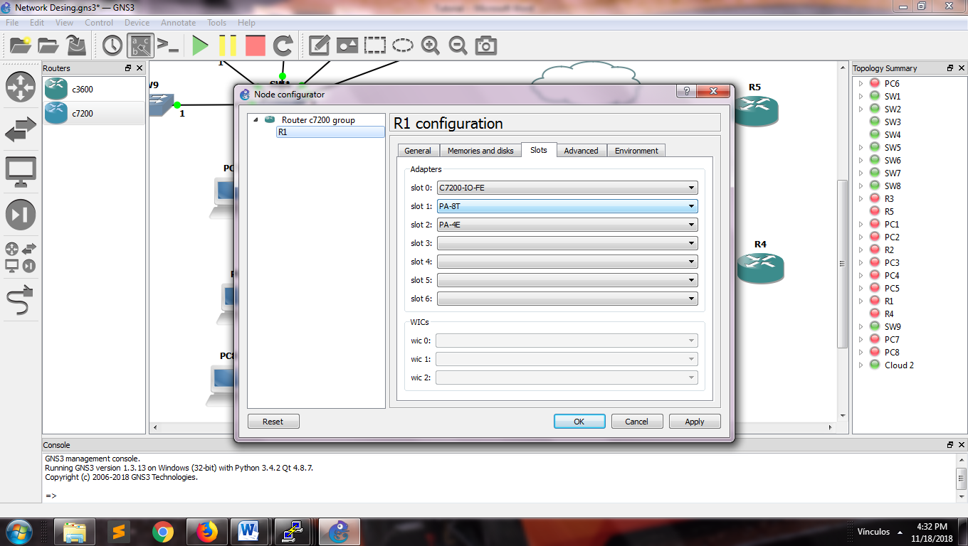

View configuration of router slots

Next step will be to configure a network that connects the main router with the department router. We use the ip address showed below in the table:

|  |  |  |  |  |
| --- | --- | --- | --- | --- |
| Network address | Router | Router address | Interface main router (R1) | Interface address |
| 172.16.0.0/30 | R2 | 172.16.0.2 | Ethernet 1/0 | 172.16.0.1 |
| 172.16.1.0/30 | R3 | 172.16.1.2 | Ethernet 1/1 | 172.16.1.1 |
| 172.16.2.0/30 | R4 | 172.16.2.2 | Ethernet 1/2 | 172.16.2.1 |
| 172.16.3.0/30 | R5 | 172.16.3.2 | Ethernet 1/3 | 172.16.3.1 |

Table network WAN ip address

The commands are the follows:

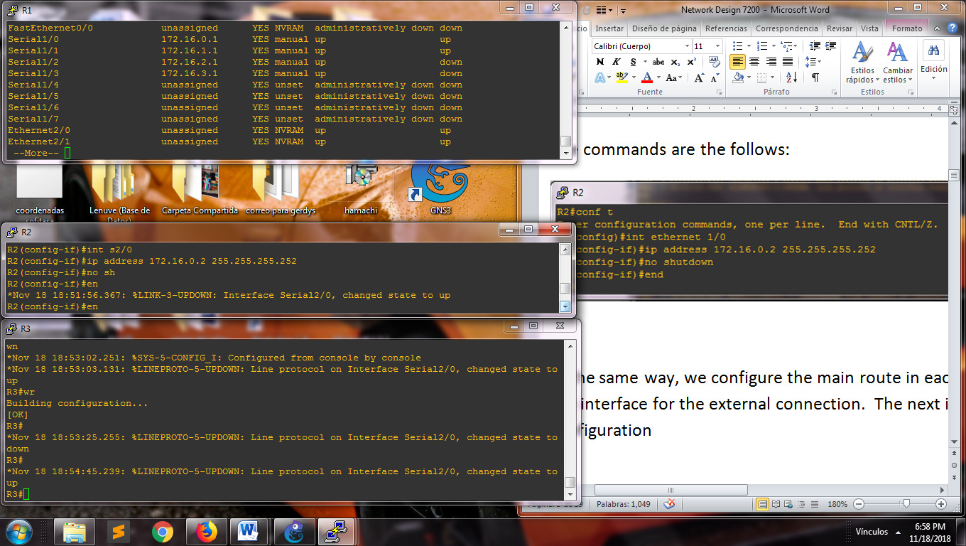

Commands lines for configure the WAN

In the same way, we configure the main route in each interface connected to the routers and the interface for the external connection. The next image show each interface with its configuration.



View main router

We can try the connection using the ping command with the direction of the router

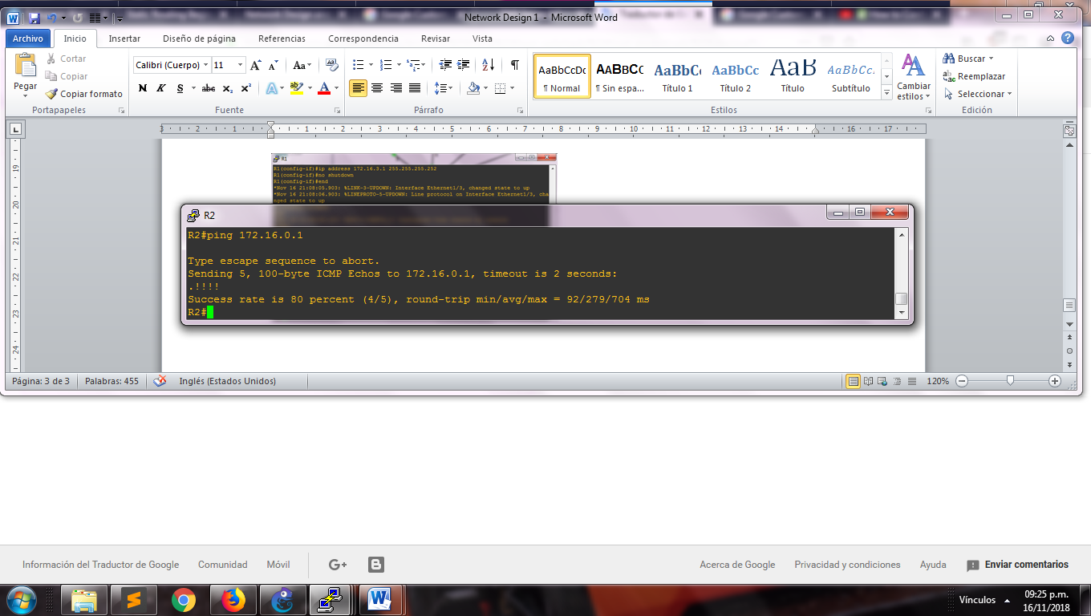

View check the connection

Note: If it shows a high percentage of send, then the routers have a good communication.

Now configure the switches with the name of the VLANs that it will be used into of each department.

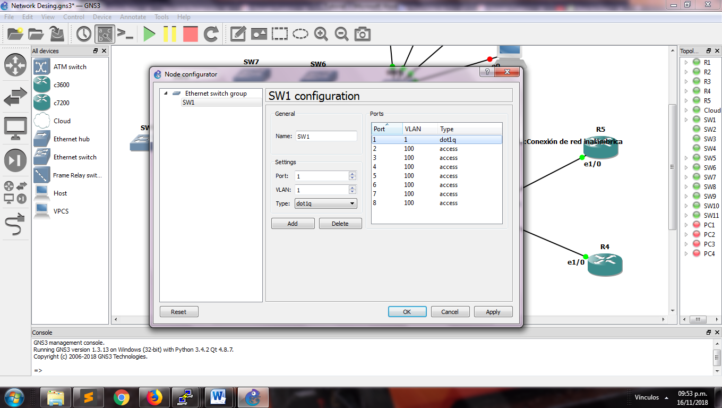

Configuration of the VLANs

Our ip configurations in the PCs are going static, put each one in its console corresponding in the next command line:

ip 192.168.168.3 255.255.255.128 192.168.168.1

Indicating the ip address, mask and ip address gateway corresponding

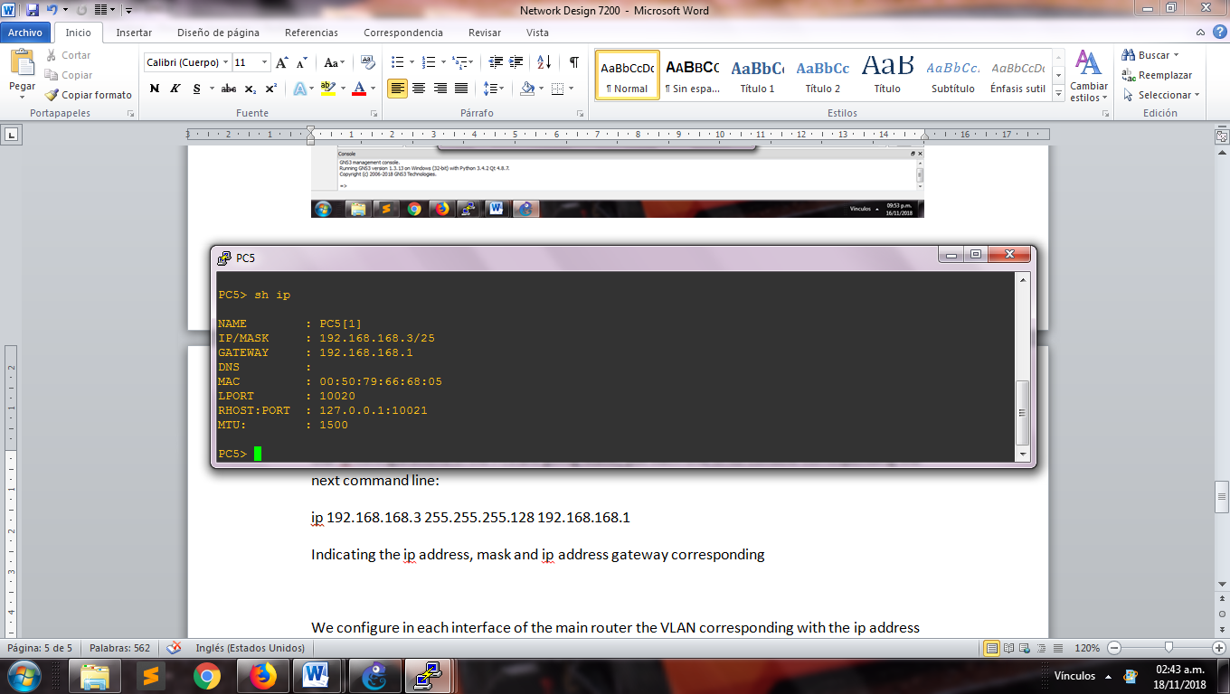

View ip address in a PC

We make a ping between the two computer configured to try that the connection is success

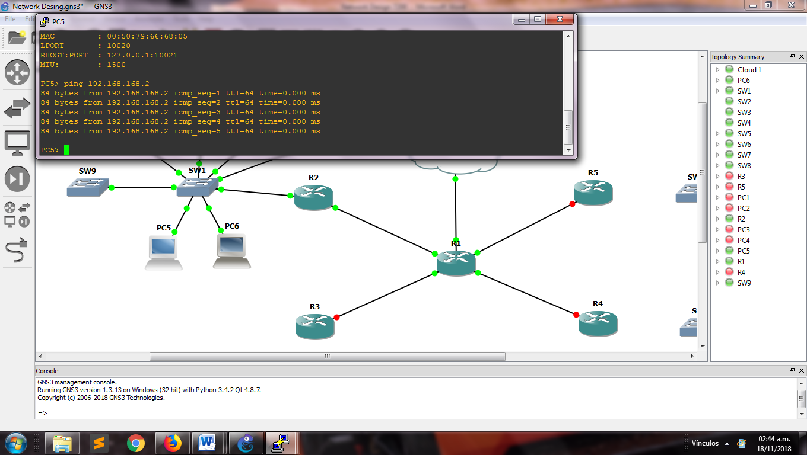

View ping success between the connections

We configure in each interface of the main router the VLAN corresponding with the ip address of the subnetting

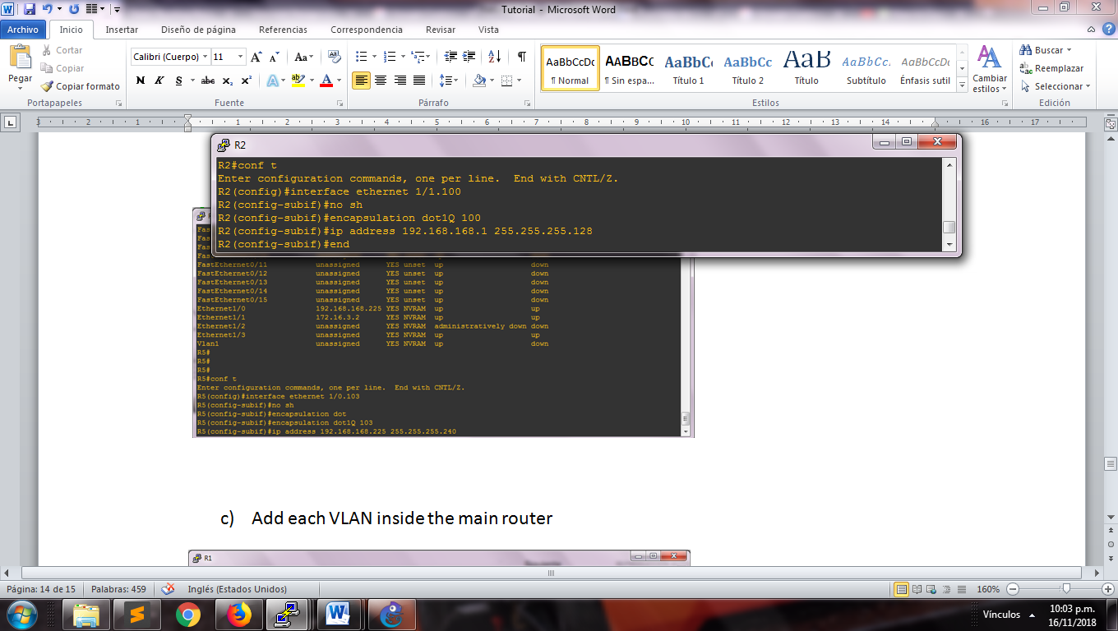

Stablish configuration of VLAN network

In the table of our interfaces should show the follow:

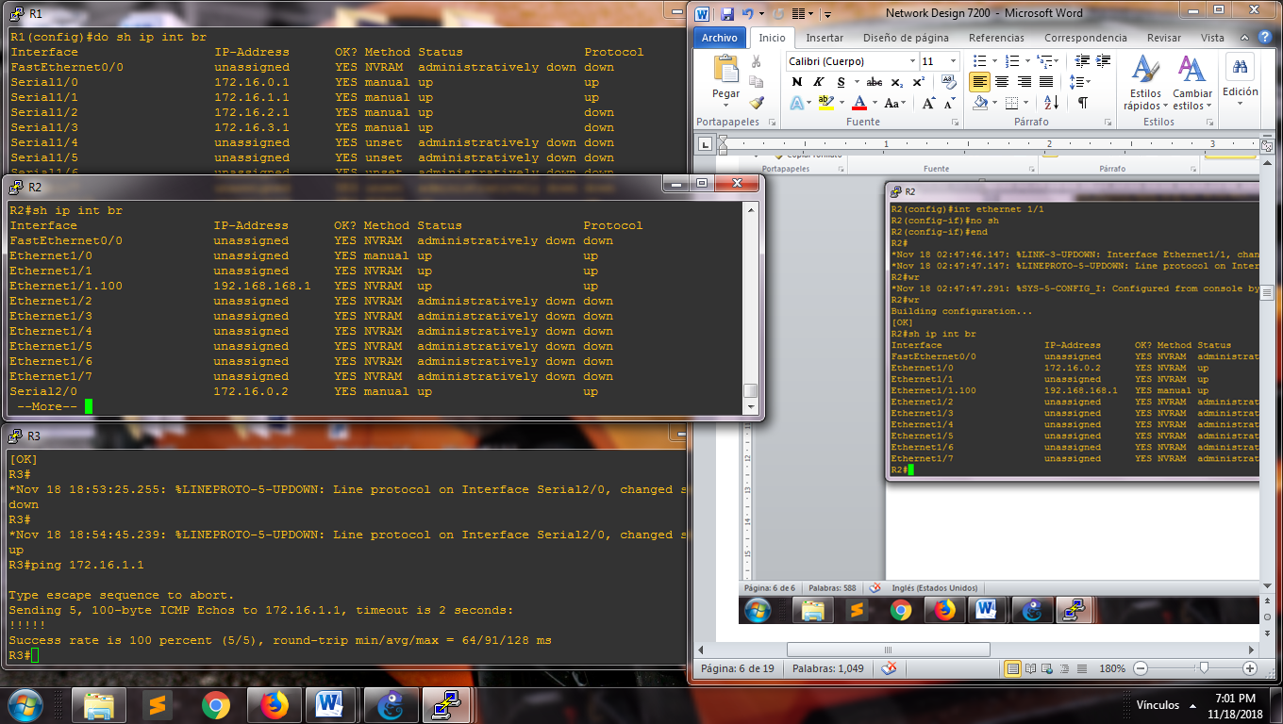

Table of interfaces R2

We try the connection between our PCs and the router R2

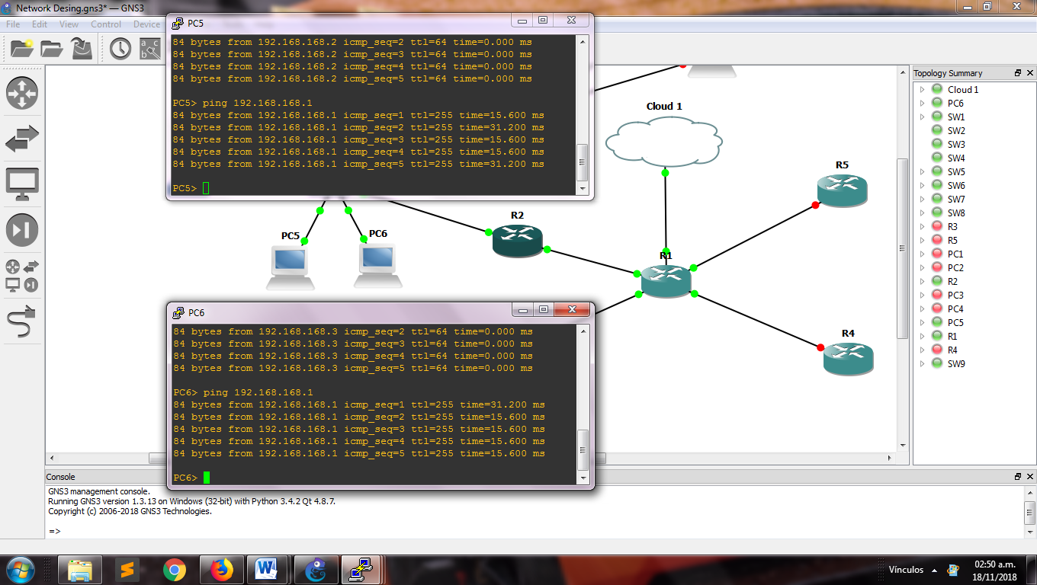

Image about connections

We configure the static route of the follow way:

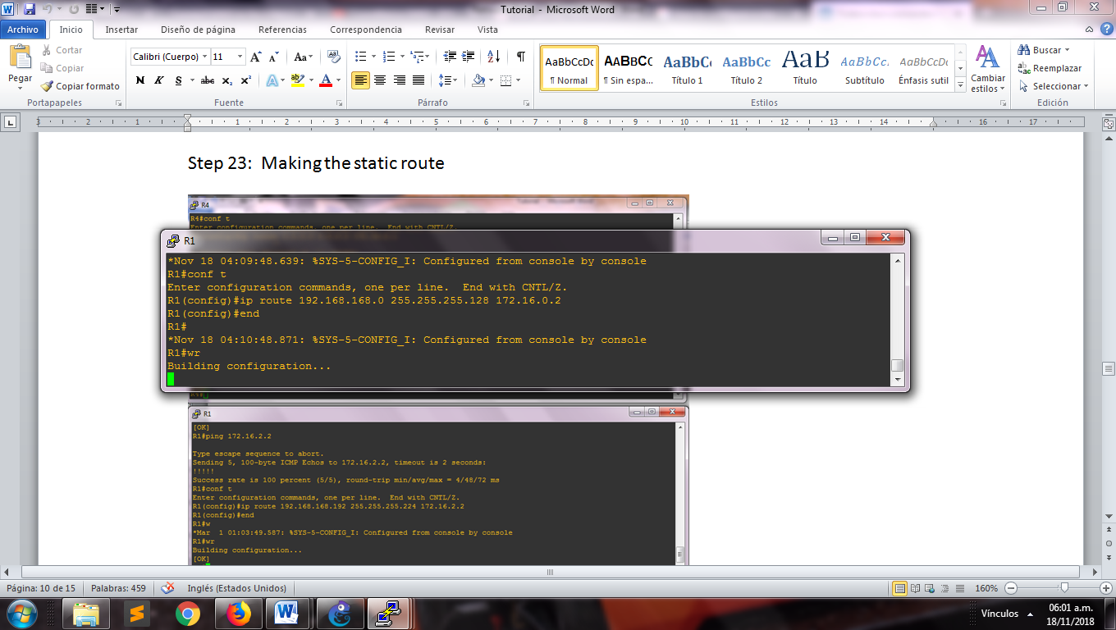

Static route in the main router

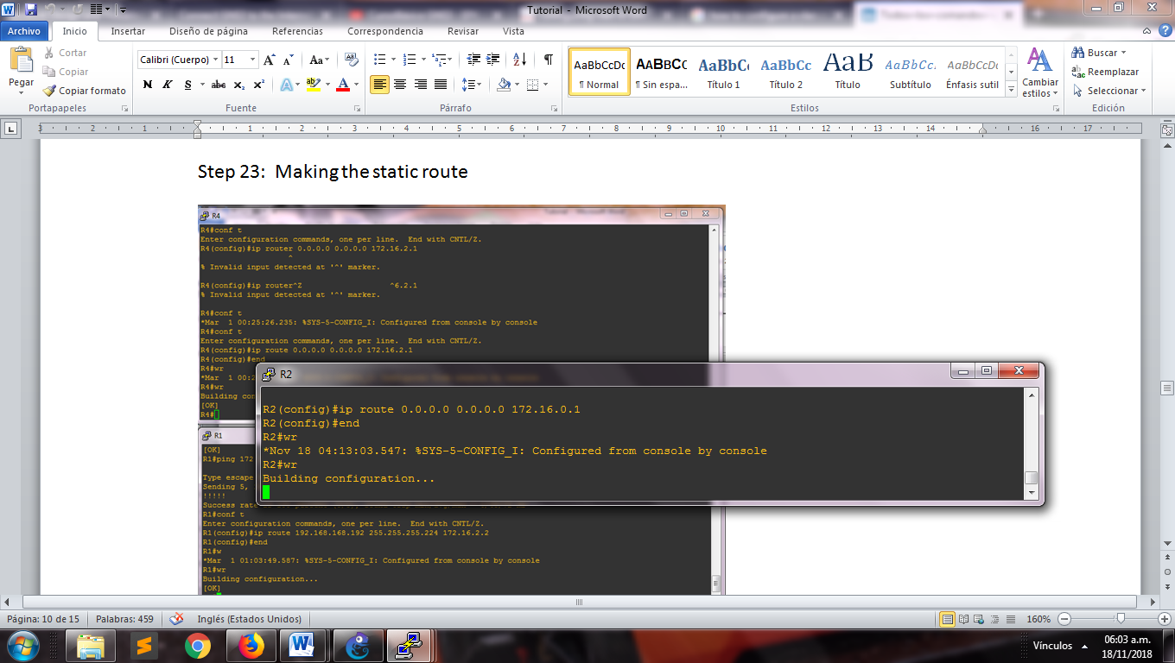

Static route in the department router

And we ping from a PC to test the connection, showing that we can already reach the R1.

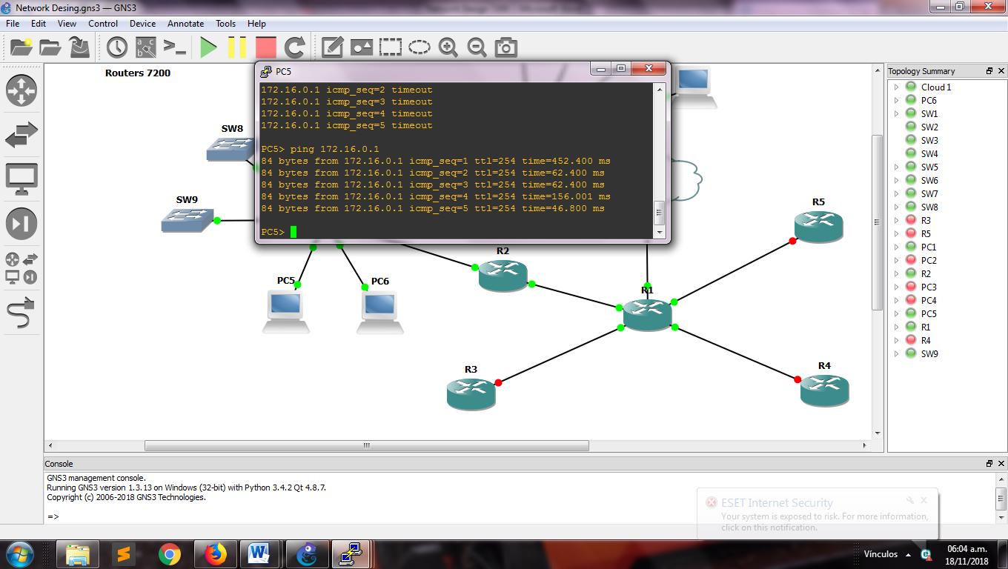

View of a ping

Now we go to create the access list for permit or deny the communication, in this case, we are going to deny the entrance the communication to others departments.

In the next image, we can watch that the R3 can communicate with the host the other department through the command ping.

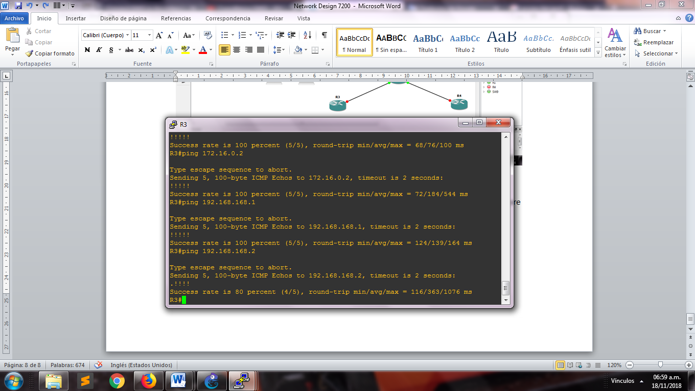

View ping made over R3

Use the next command line to create the access-list

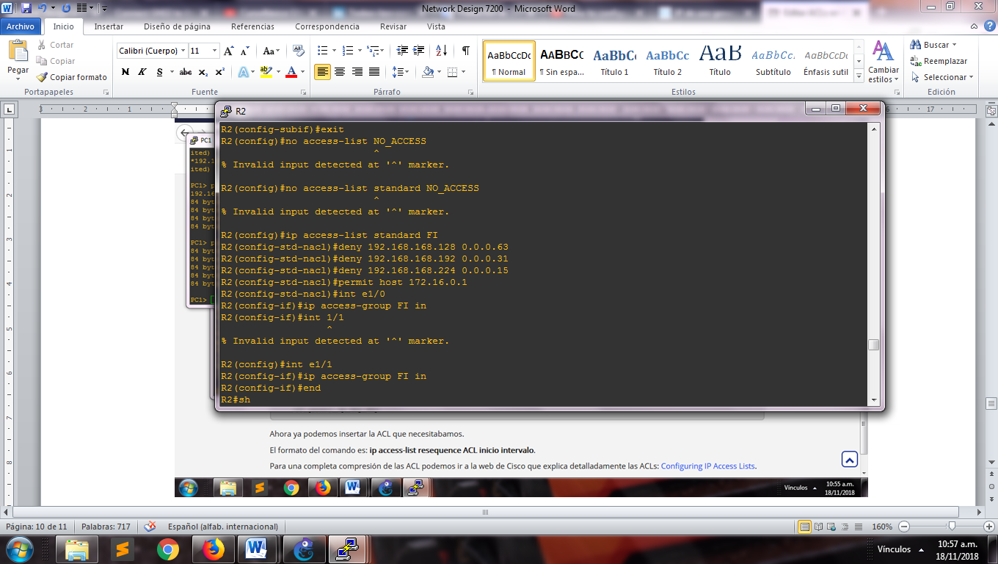

View access list for Finances department

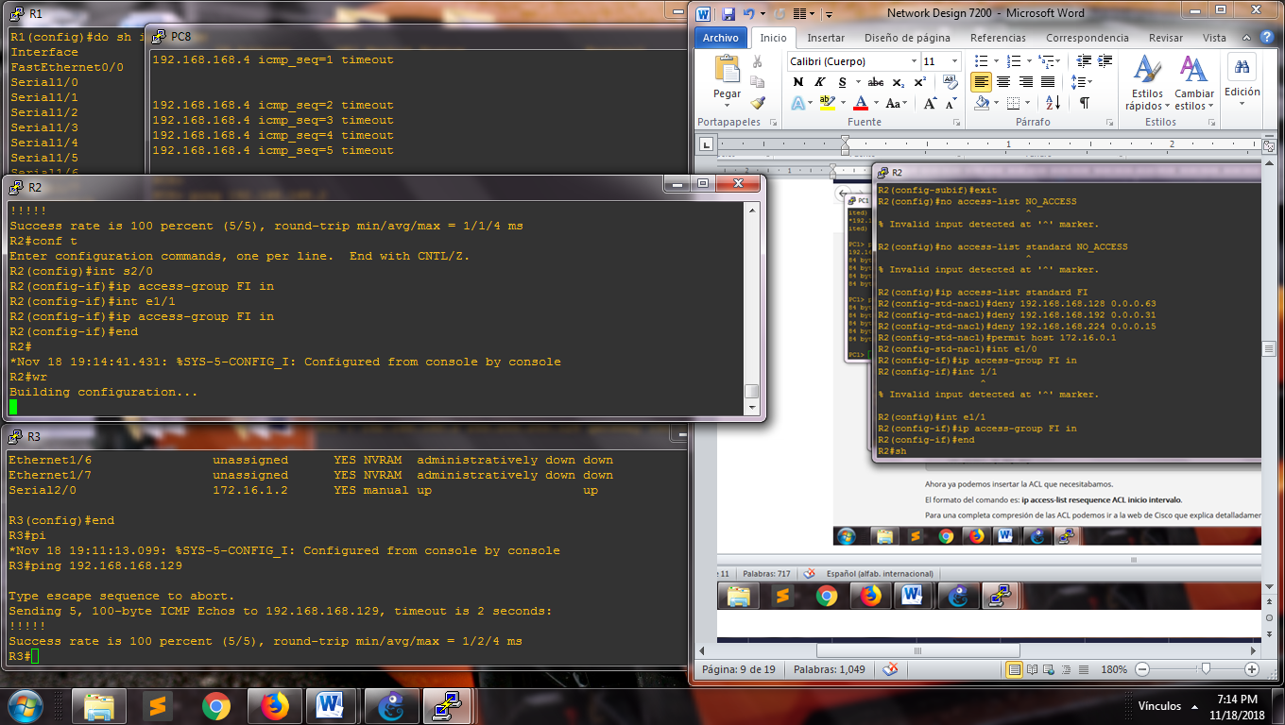

Assignment to each router interface

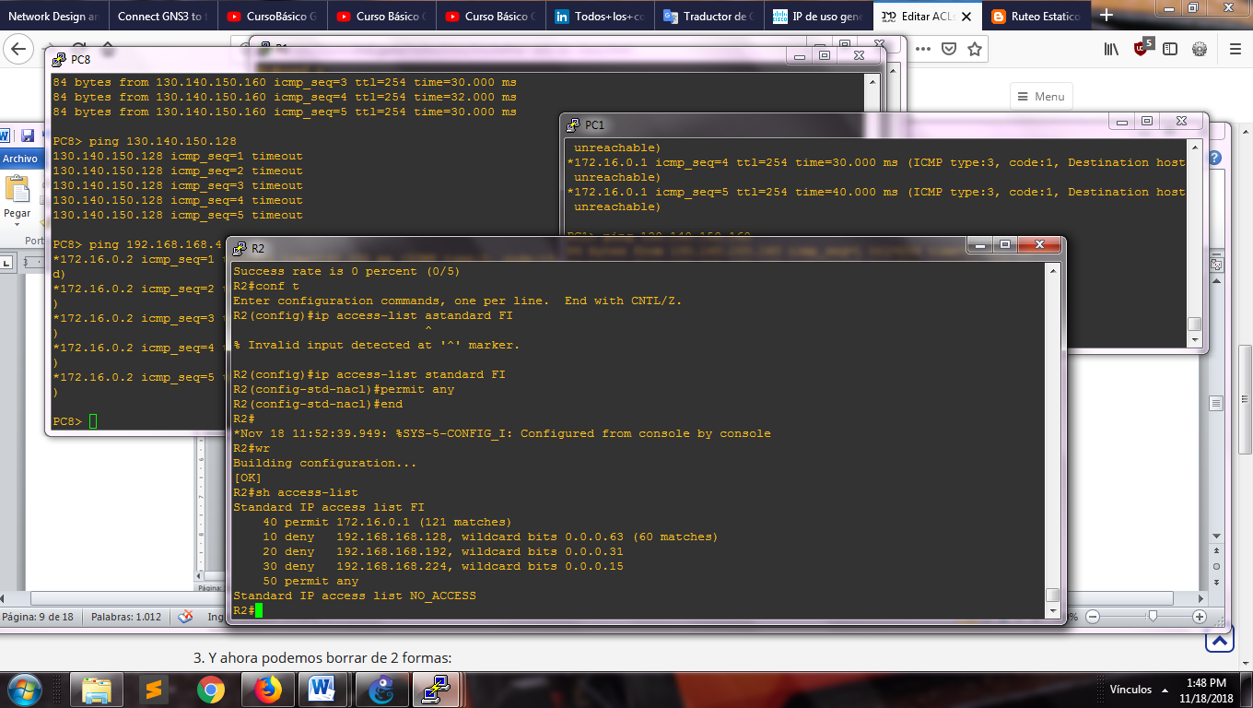

Access control list for finance department

Now for we connect to internet, we need create a loopback interface of the next way, open the cmd in our computer and typing “hdwwiz”, and will appear a window as like:

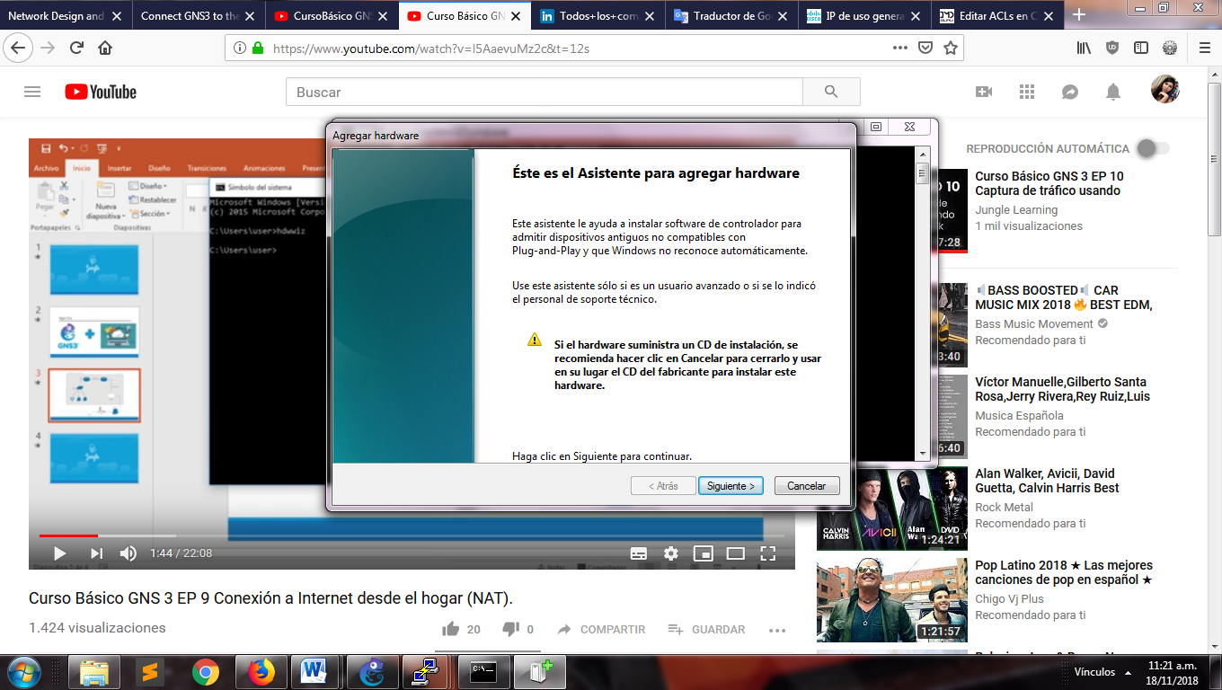

Window for help

Click in next and choose the option Install the hardware manually, search “Network Adapter” and click in “next”, choose the “Microsoft fabricator > Loopback adapter “and “next” in the other views.

In “control panel” select “center network and sharing”

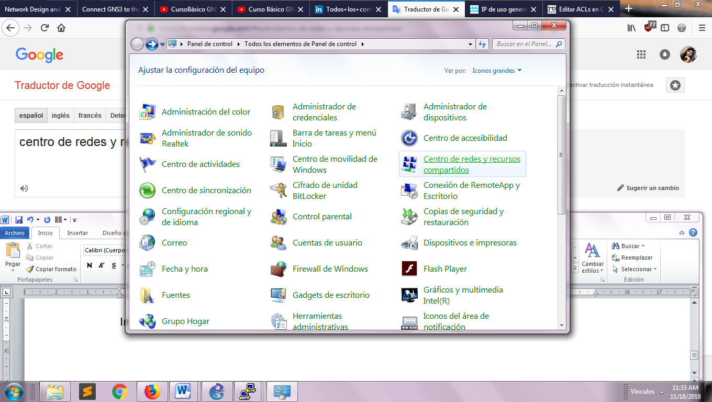

Configuration window

Click in “change the adapter configuration”

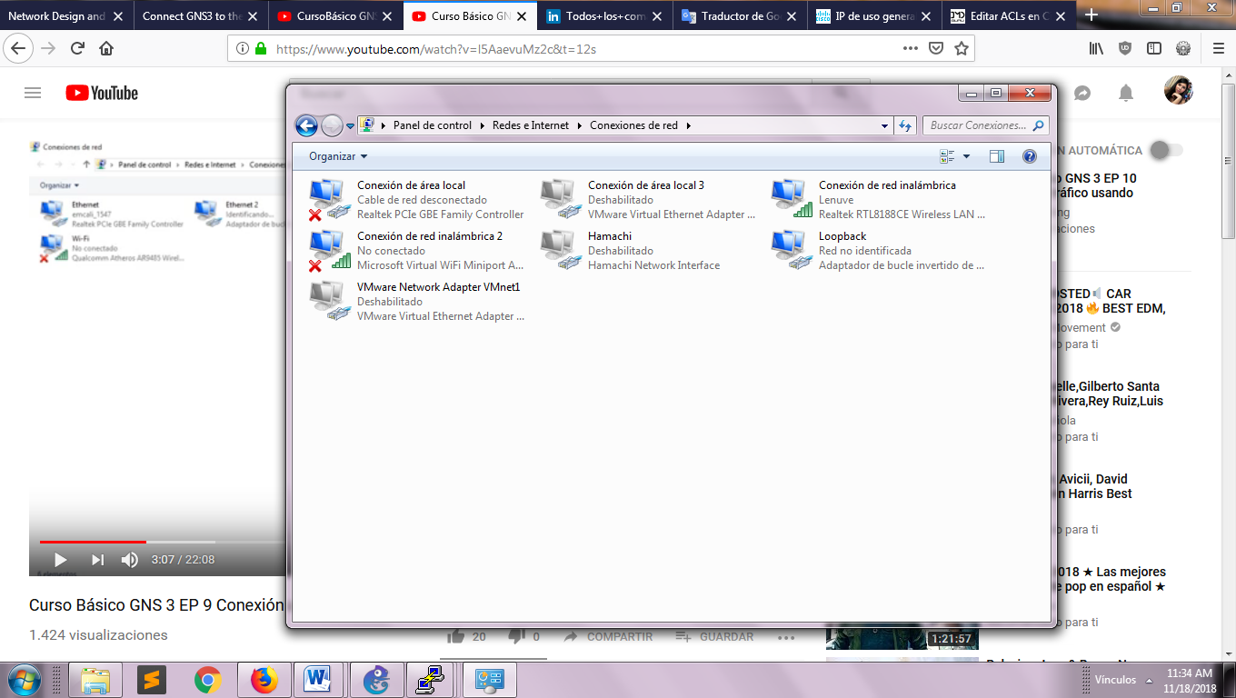

View of all the connections

Change the name to our adapter, after make right click in our adapter that it provide us internet. Click in the tab “shared use”**,** checked in the first option and choose our Loopback adapter. Click in “Ok” and reset the pc.

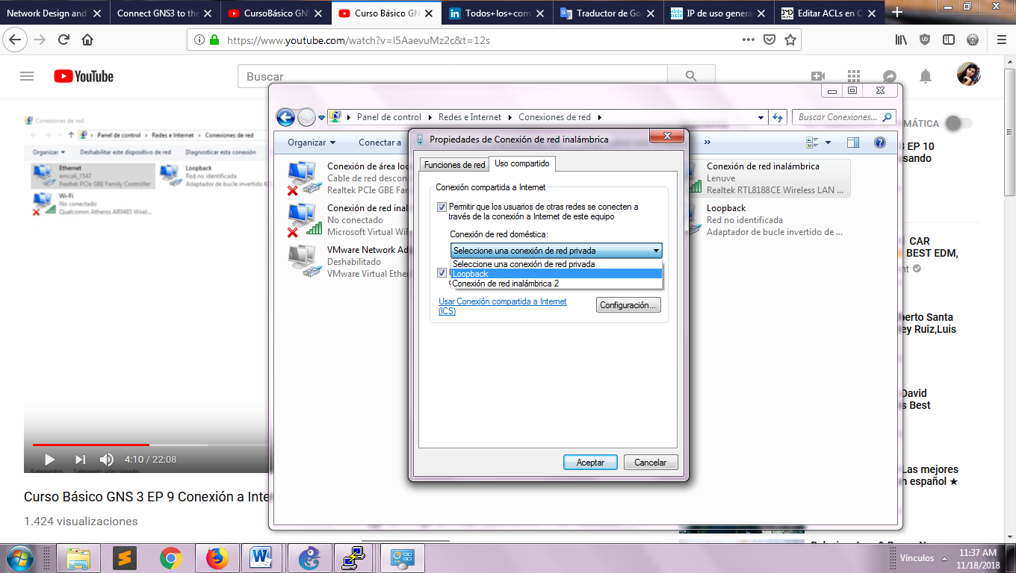

Configuration window

Select the cloud of our store of components and we put it into of the workspace.

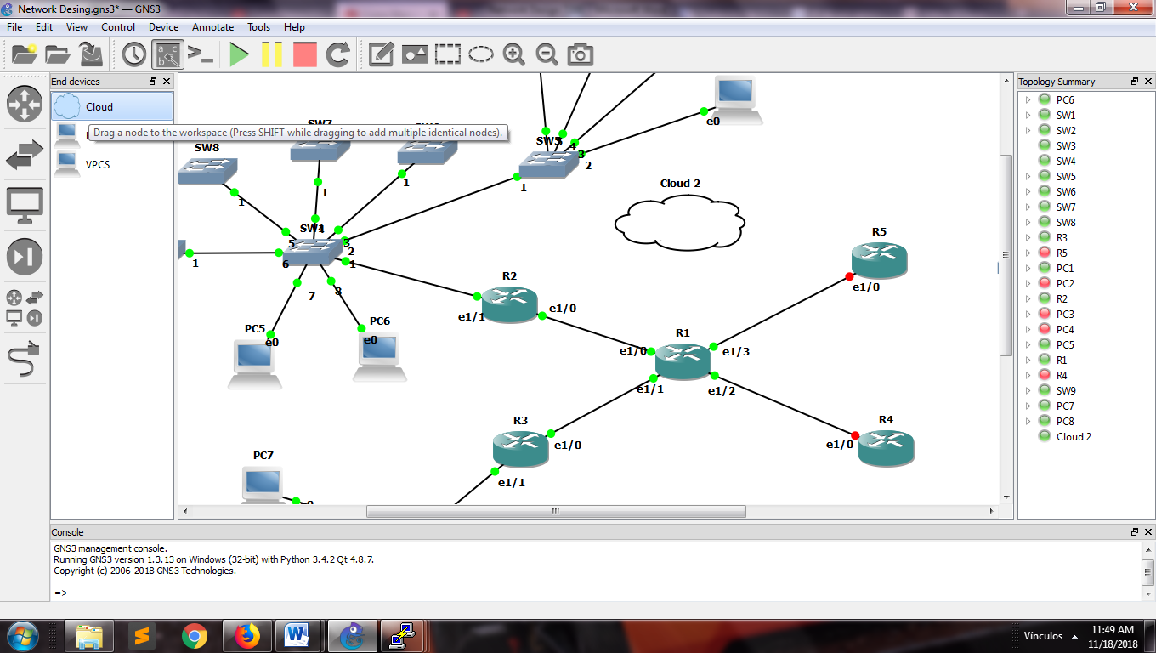

View of the workspace

Right click on the cloud > configure and select the “generic Ethernet” that we create, click on “Add” and on “Ok”.

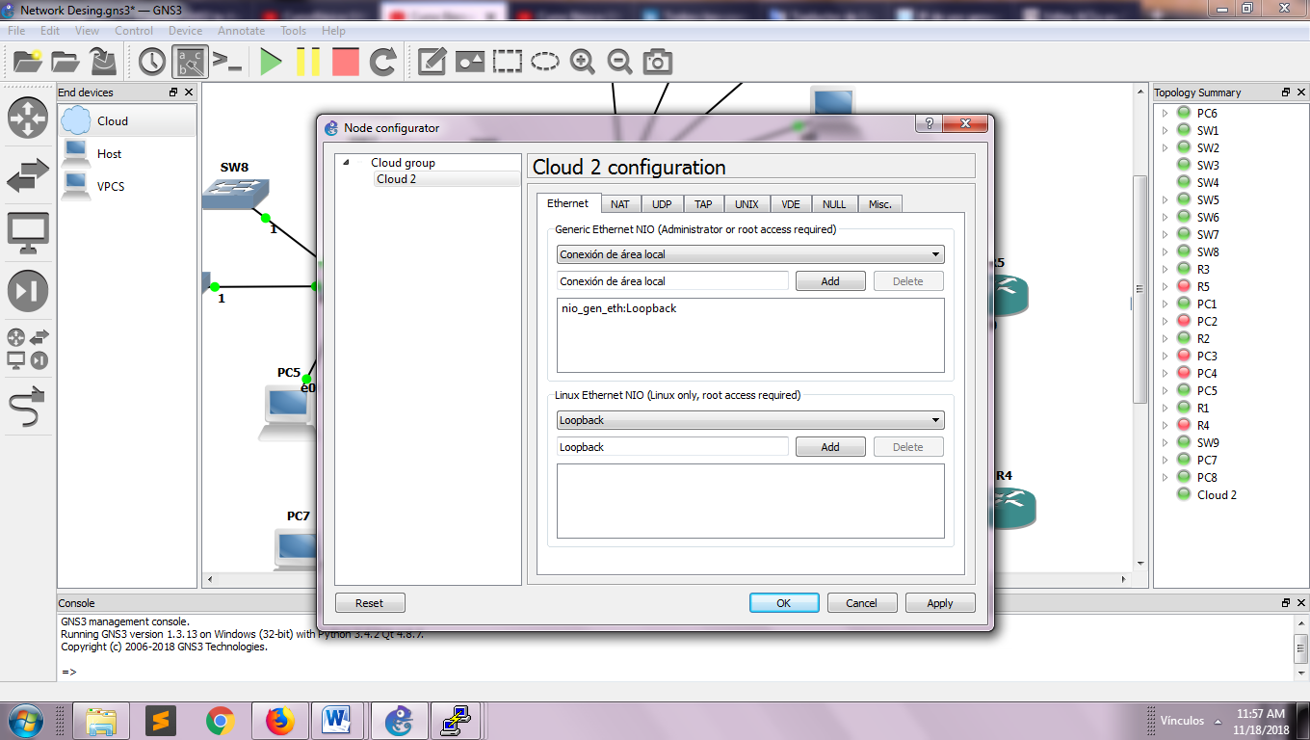

View cloud configuration

Make the connection with the Loopback interface. Into the console of router R1 typing the next lines for obtain an ip address from our real network.

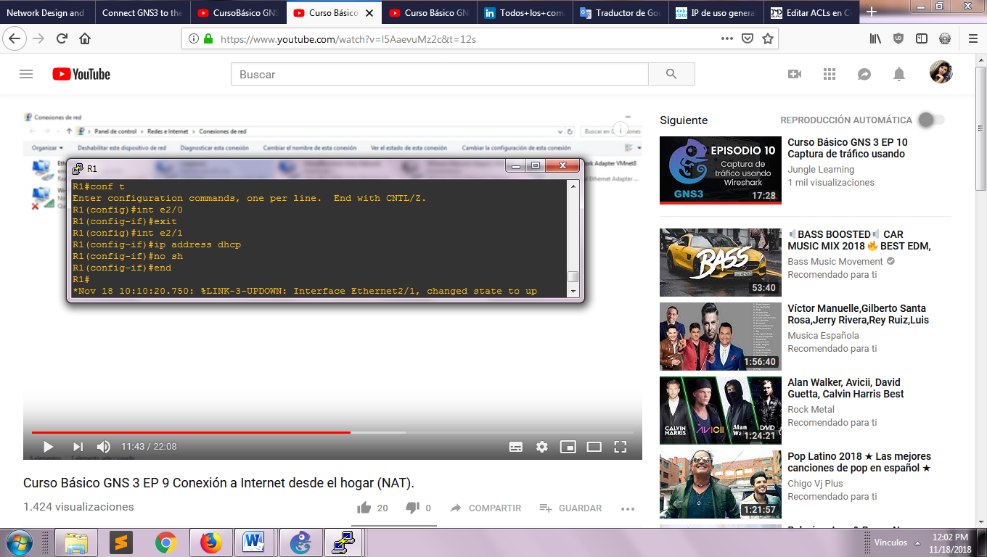

Command lines

Make ping to an ip address external of our local network for check the connection.

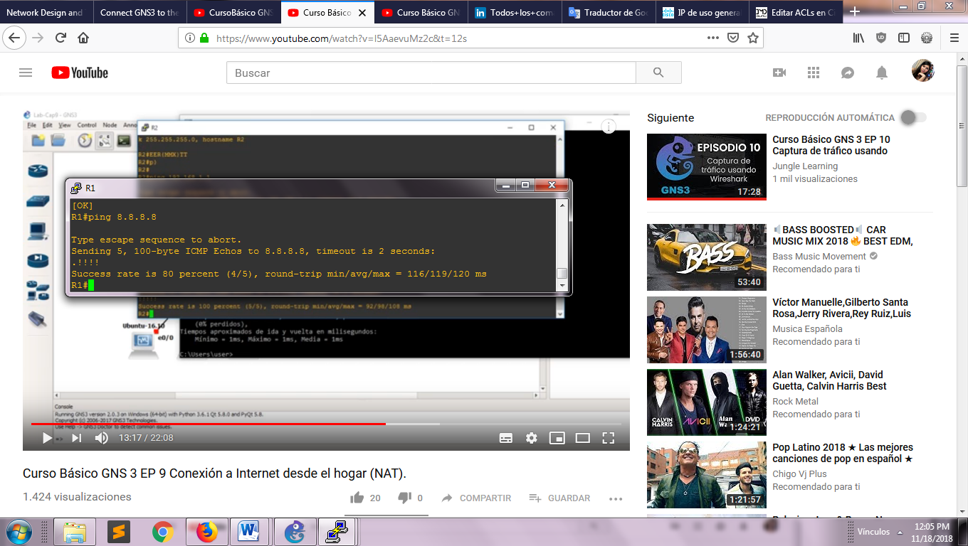

View ping to google.com

But if we try since other pc, we see that there is not connection, then for solution it we are going configure the NAT (Network address translation)

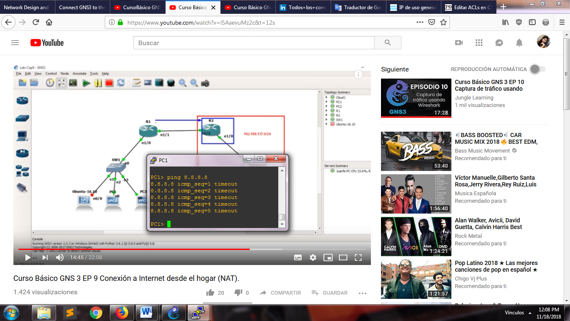

View success of ping to google.com

First we see which are the inside interfaces that we want to change, in the design are four (e1/0, e1/1, e1/2, e1/3), and existing one outside interface (e2/1)

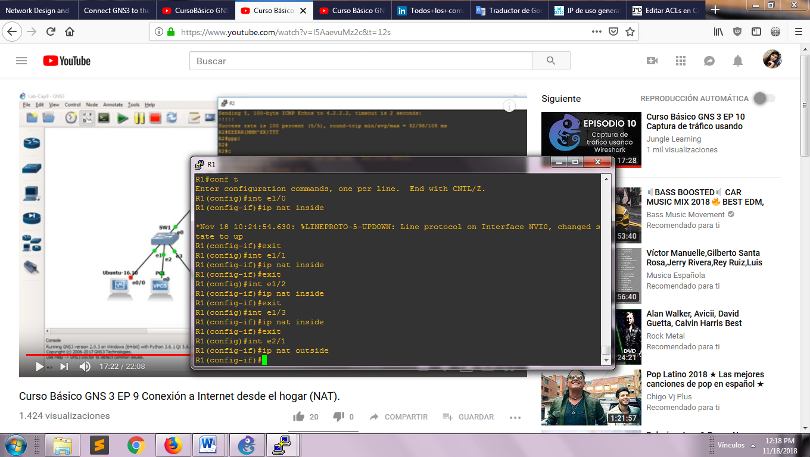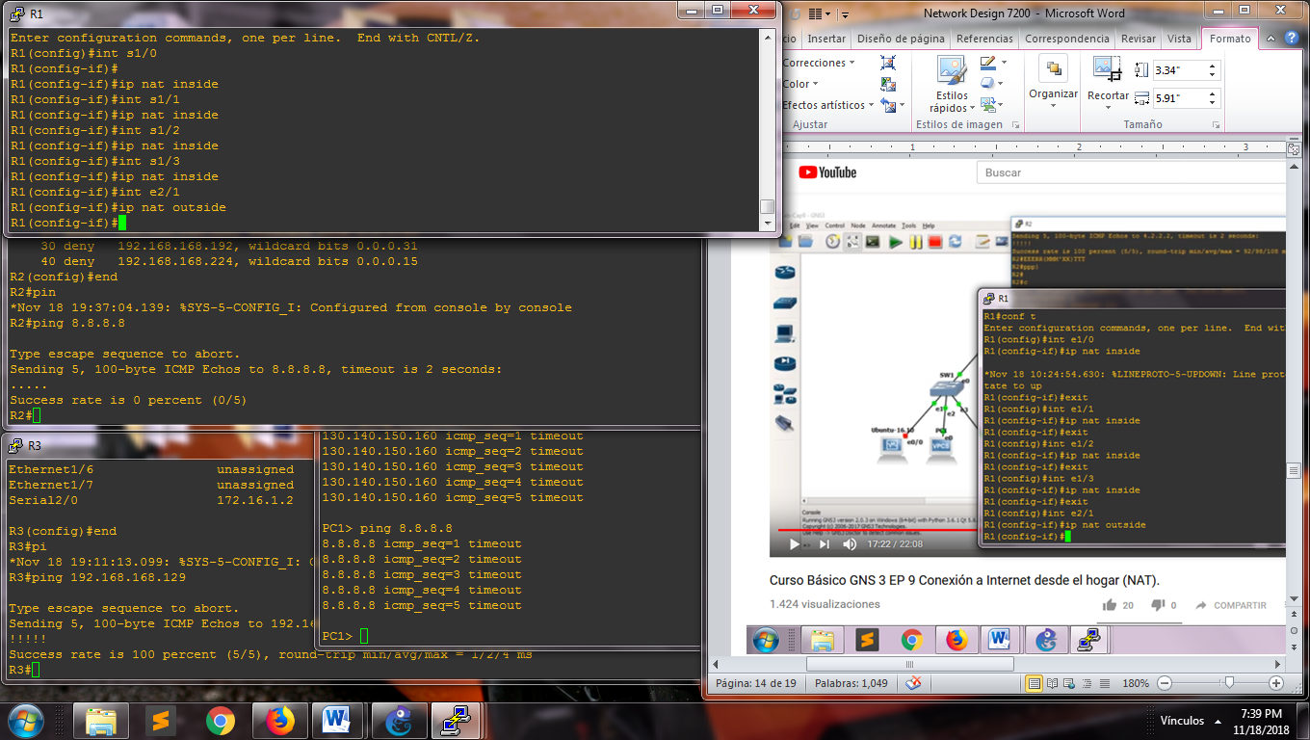

View interface configuration

After, we create a access list for permit all the ips address that can be to transform with NAT, using dynamic mapping.

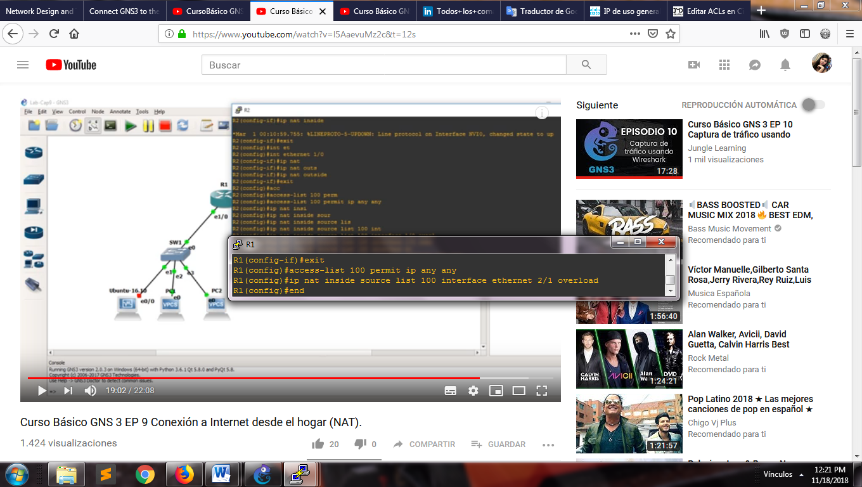

View for permit all the ip direction

Configure the Loopback interface in the router R1

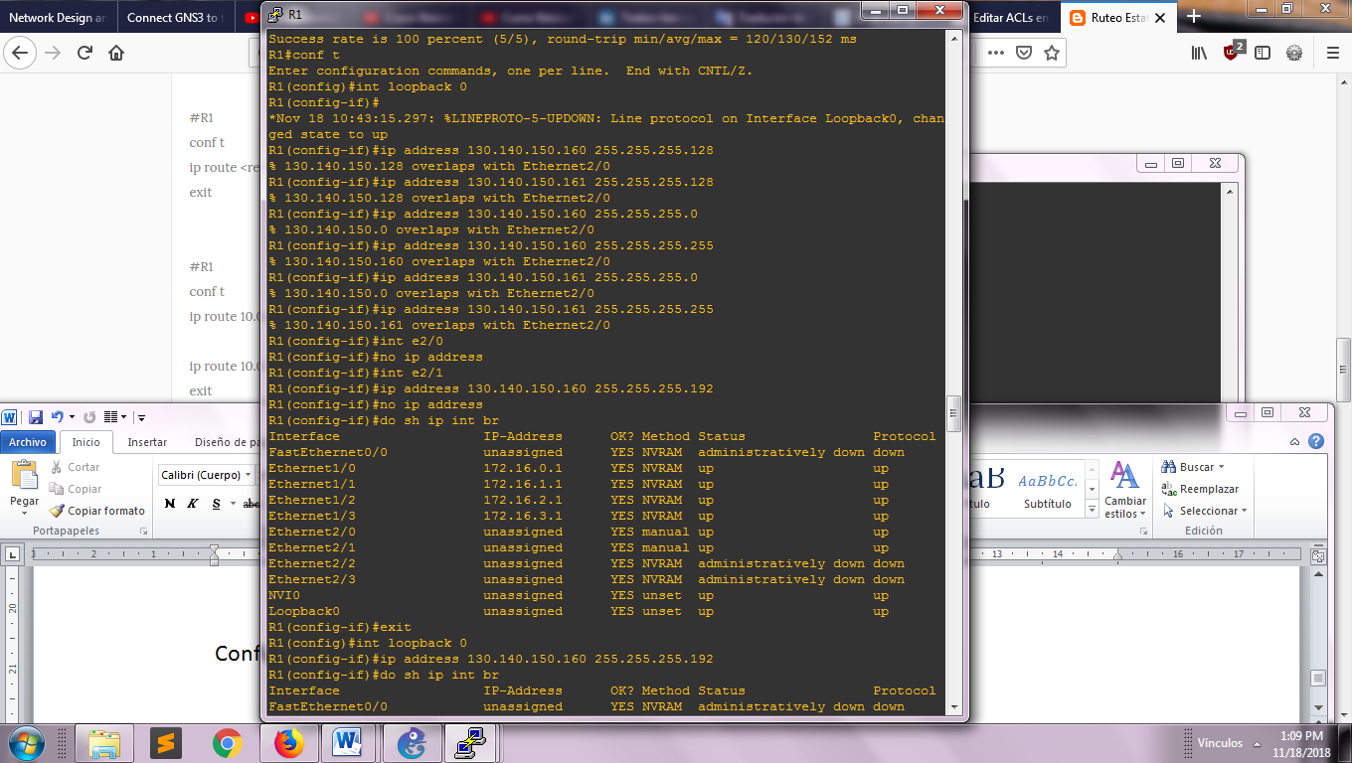

View Interface Loopback

The address obtain is 130.140.150.128, the next table is shown with the command “sh ip route**”**

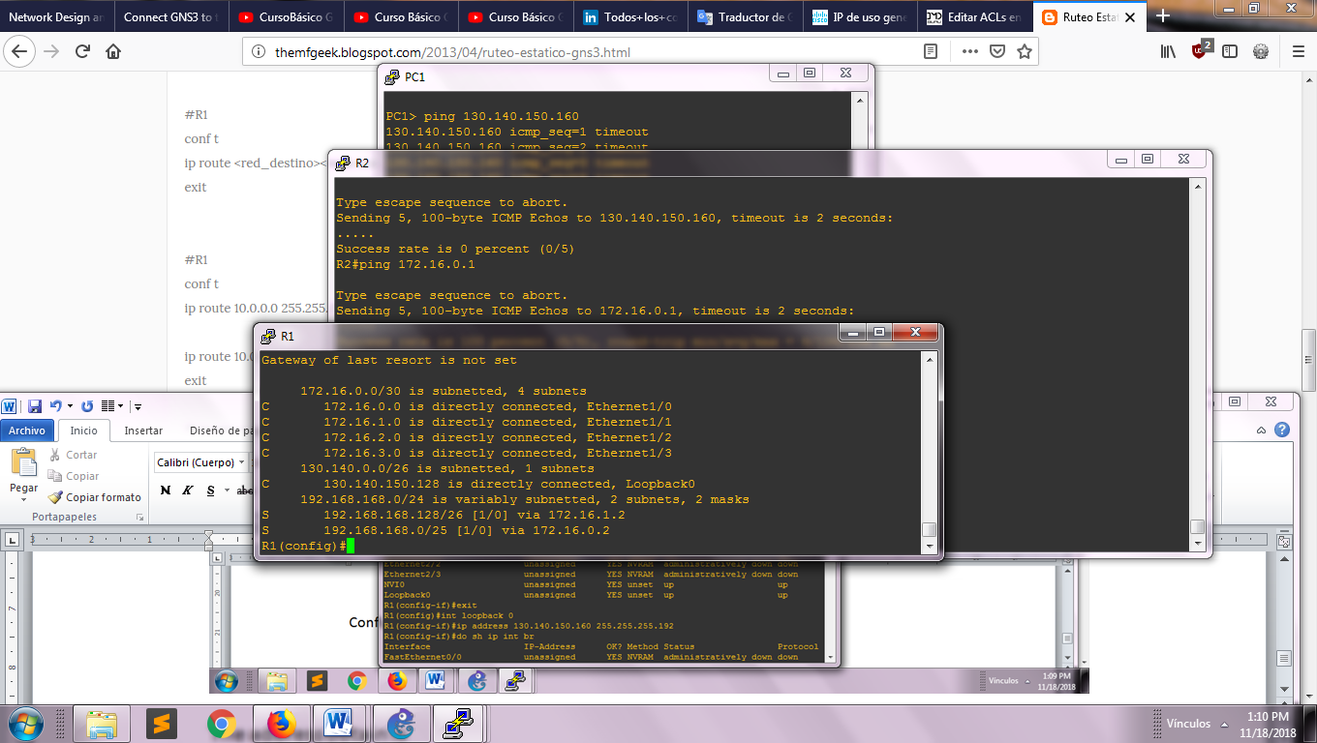

View route table

We can procedure to configure the DNS server of the next way:

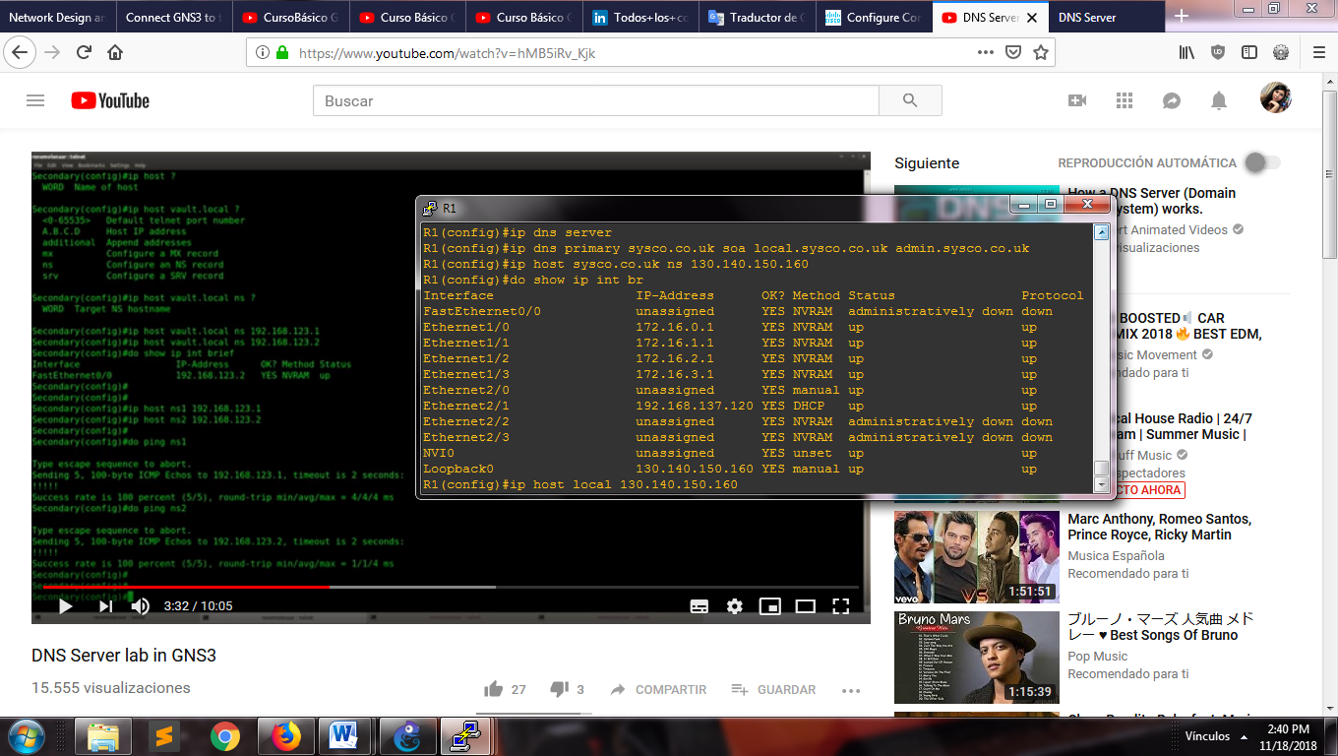

Command lines for DNS

In the routers for each department configure the next it:

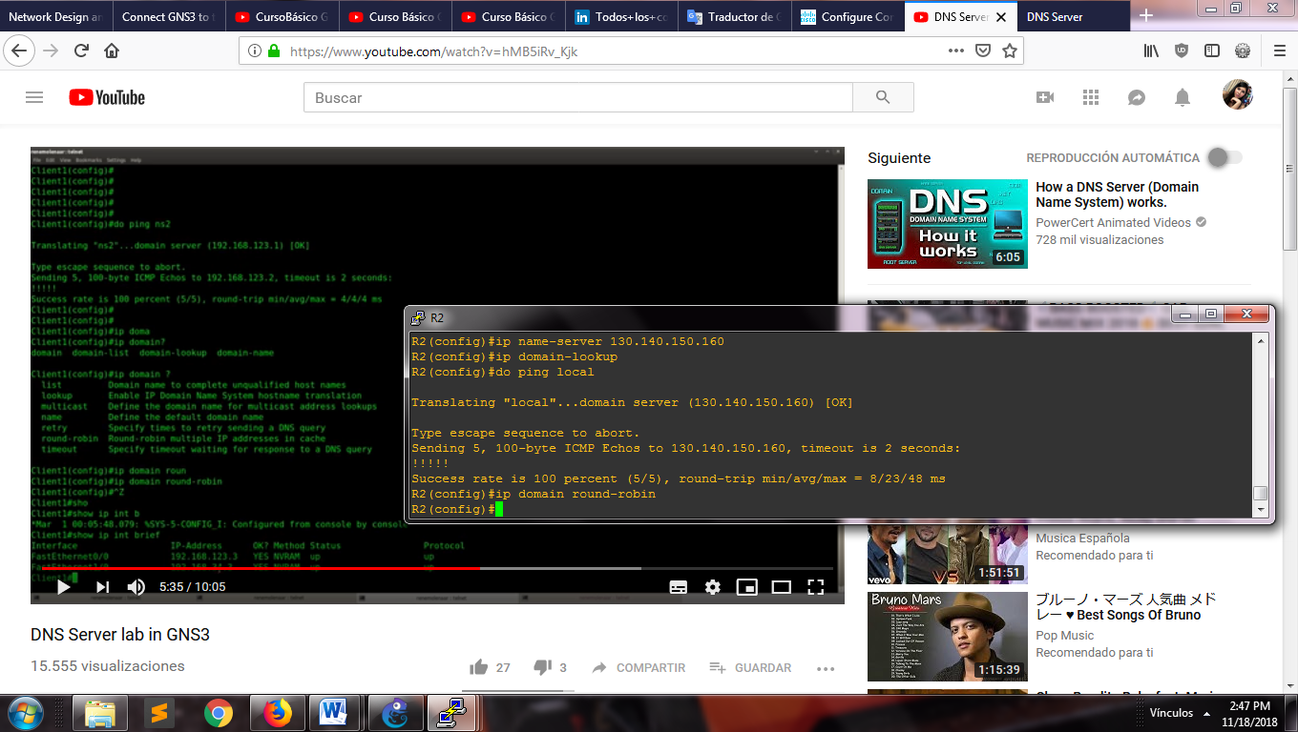

View for obtain the DNS

We use the PAP method authentication in the network WAN between the routers with the protocol PPP of the next way

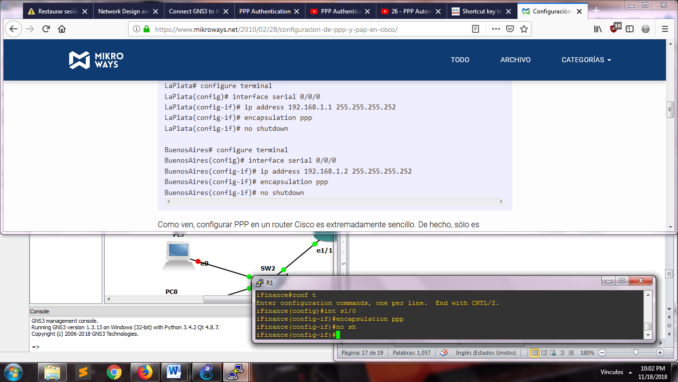

Command lines for encapsulation main router

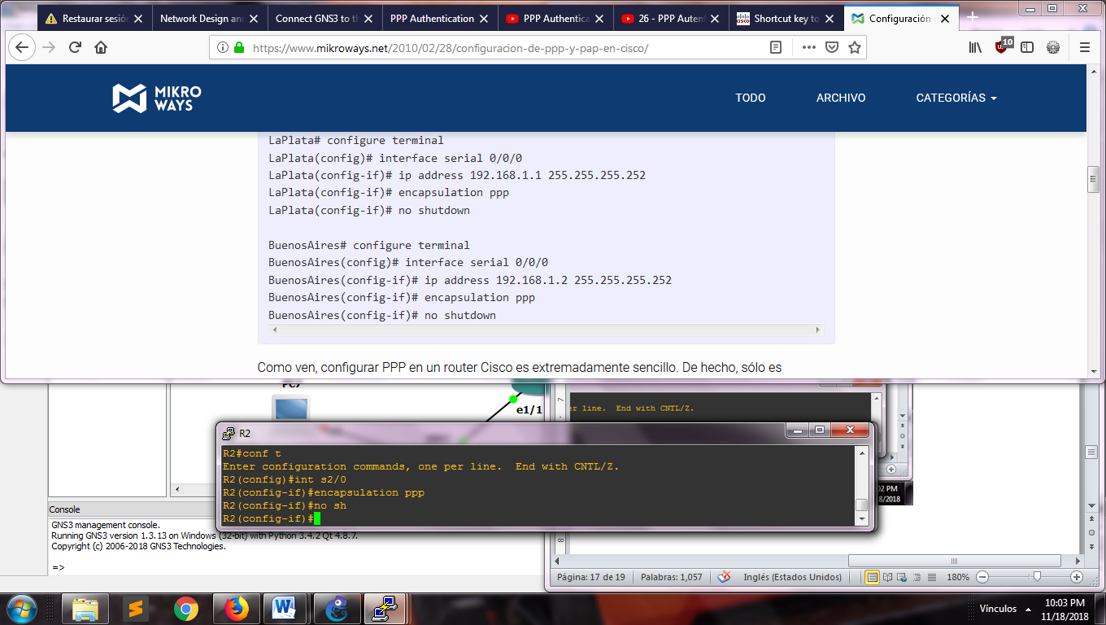

Command lines for department router

Now for the authentication, add PAP in this configuration of the next way in a unidirectional sense, stablish one router that send its user and password and the other wait to receive it, else it will be rejected:

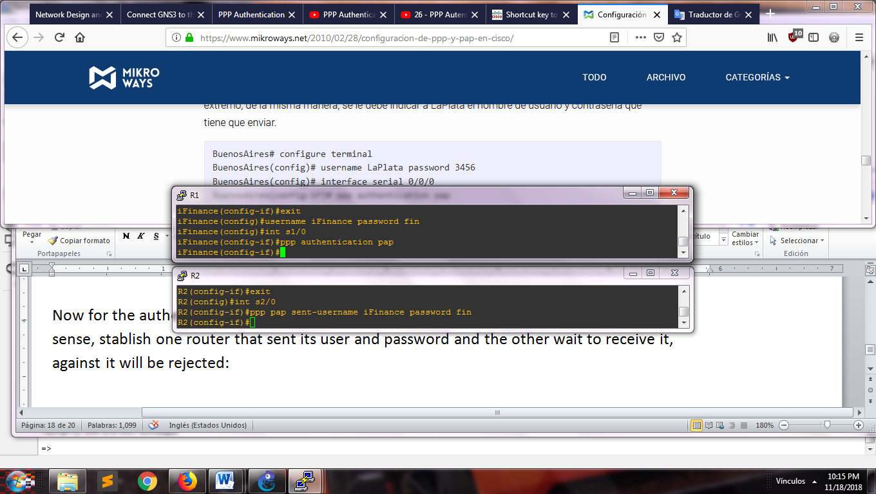

Configuration for authentication

And this way, we can see that the exist an authentication between the routers successfully, when R1 show us the next message

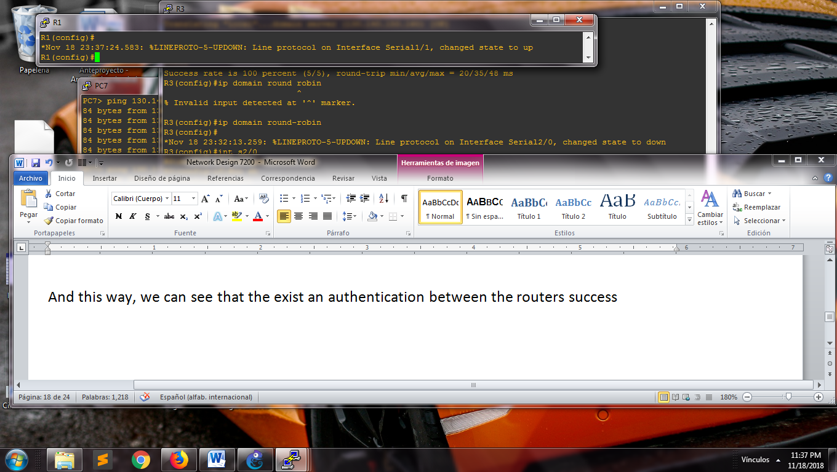

Message success

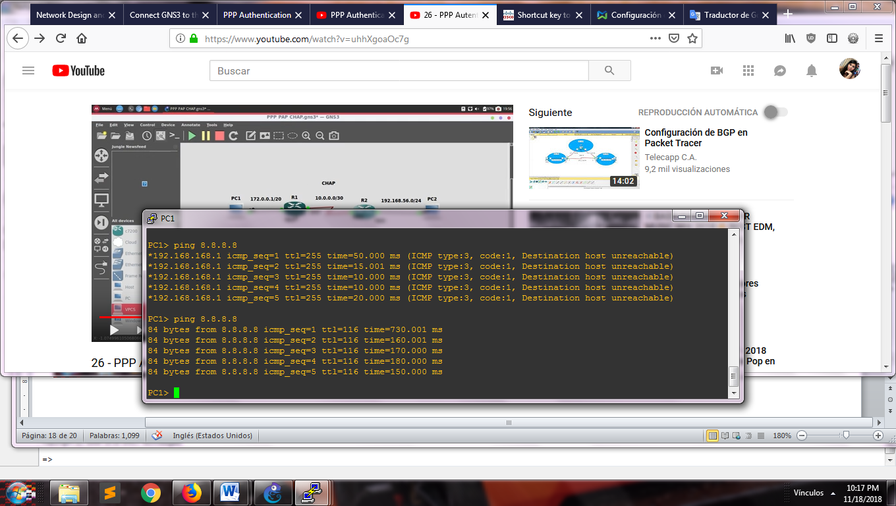

Connection to internet

For put the ip address to each host automatically, we configure the DHCP in each router with the next command lines:

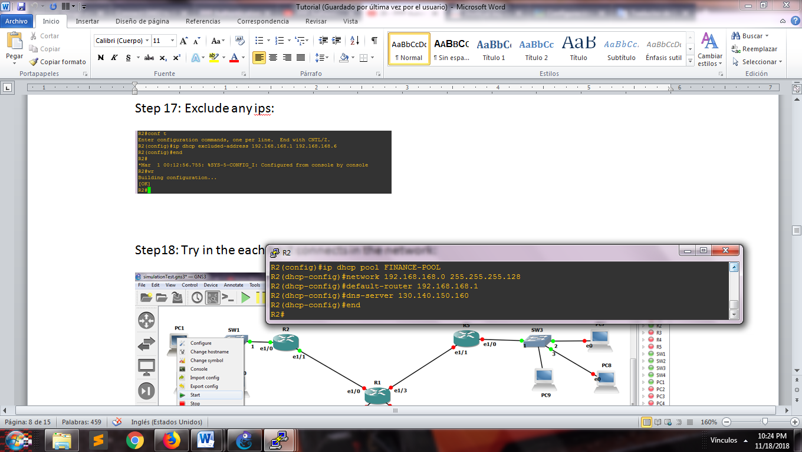

Command lines to create a dhcp pool

We can exclude any ips for avoid duplicate with the address of the network, the server and the printer.

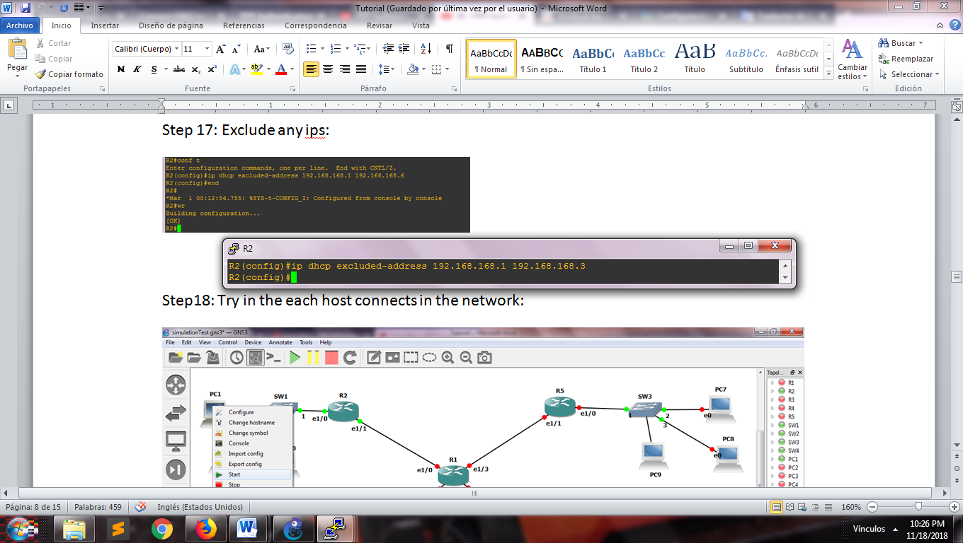

Command for exclude ips

At the first moment, the host will be without the ip address.

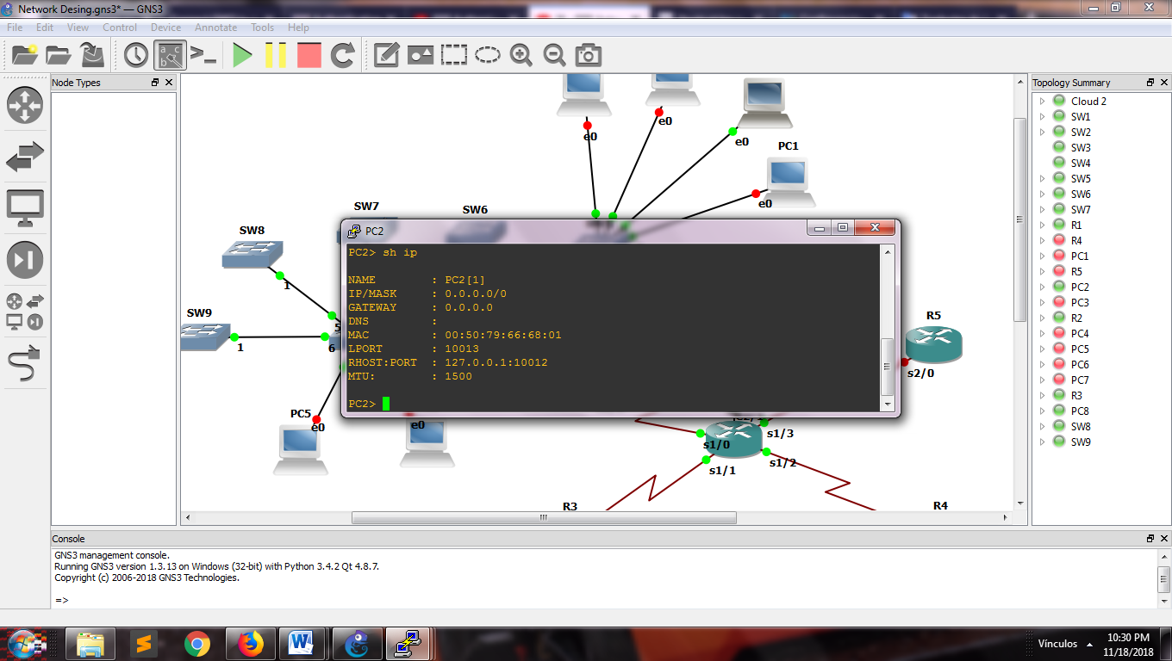

View a console ofpc

We assignment it through of the command DHCP and the same way, we check the connection with the network

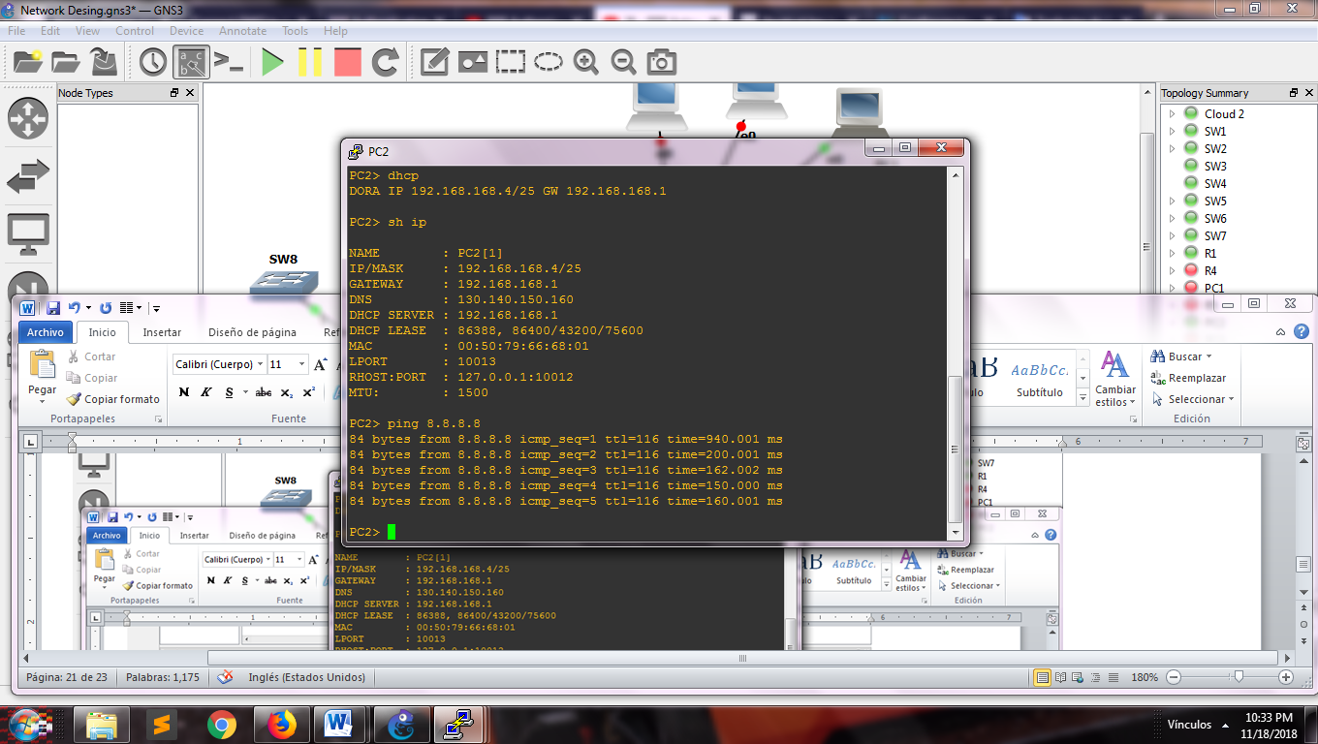

Assignment of ip with dhcp

Change the symbol of the components server and printer doing right click over the element, click in “Change symbol”.

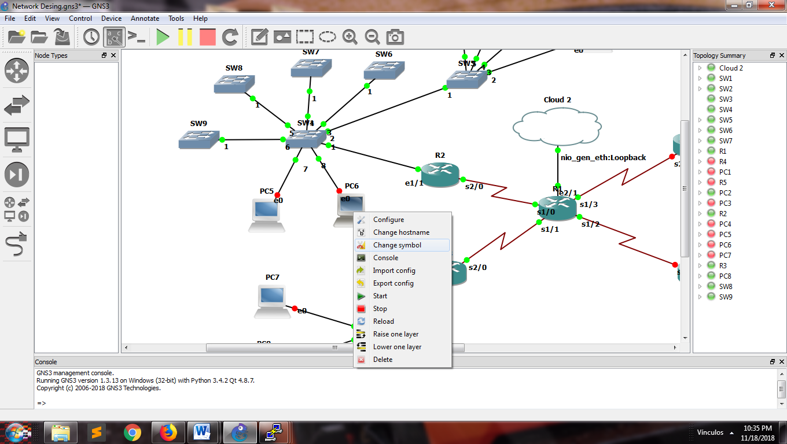

View for change the symbol of the component

Select the image that represents the component and click on “Ok”

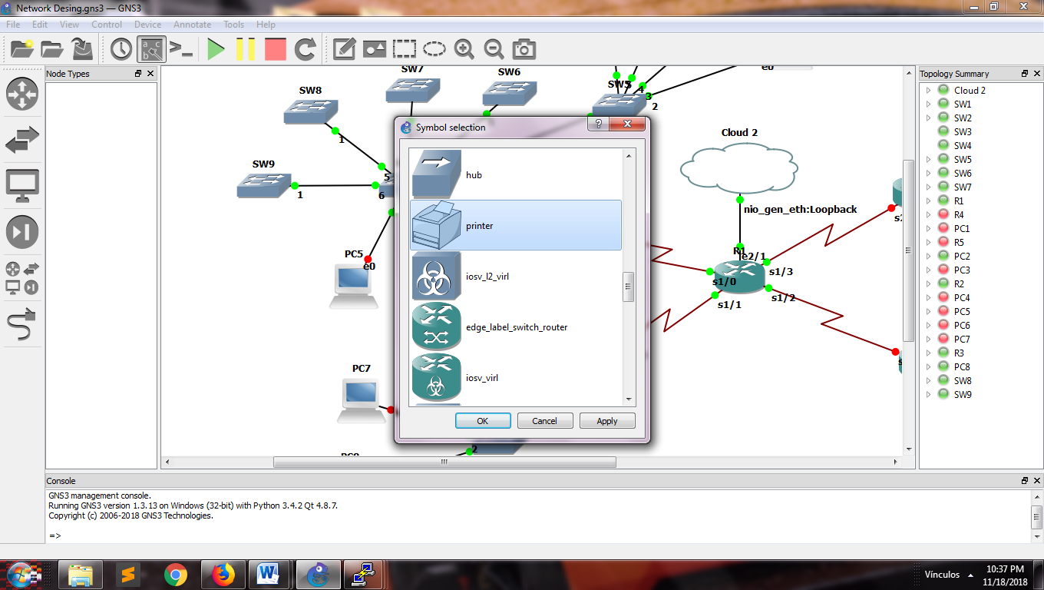

View for select the symbol

**REFERENCES**

* Cisco.com,(2018). *Cisco Official Website*. [online] Available at: [https://www.cisco.com/](https://www.cisco.com/c/en/us/support/docs/ip/access-lists/26448-ACLsamples.html) [Accessed Nov. 2018]
* gns3vault.com,(2018). GNS3 VAULT *Official Website*. [online] Available at: https://gns3vault.com /[Accessed Nov. 2018]
* gns3.com,(2018). *Documentation GNS3 Official Website.* [online] Available at: https://docs.gns3.com/[Accessed Nov. 2018]
* Youtube.com,(2011). *DNS Server lab in GNS3.* [online] Available at: <https://www.youtube.com/watch?v=hMB5iRv_Kjk>/[Accessed Nov. 2018]